

**AMERICAN INTERNATIONAL UNIVERSITY–BANGLADESH (AIUB)**

**FACULTY OF SCIENCE & TECHNOLOGY**

**DEPARTMENT OF PHYSICS**

**PHYSICS LAB 1**

**Summer 2020-2021**

**Section: D , Group: 1**

**LAB REPORT ON**

***To determine the temperature coefficient of resistance of the material of a wire.***

**Supervised By**

**Bithi Paul**

**TABLE OF CONTENTS**

|  |  |
| --- | --- |
| **TOPICS** | ***Page no*.** |
| 1. **Title Page** | 1 |
| 1. **Table of Content** | 2 |
| 1. **Theory** | 3-4 |
| 1. **Apparatus** | 5 |
| 1. **Procedure** | 6 |
| 1. **Experimental Data** | 7 |
| 1. **Calculation** | 7 |
| 1. **Result** | 8 |
| 1. **Discussion** | 8 |
| 1. **References** | 9 |
|  |  |

1. **Theory**

Temperature coefficient of resistance is the property of the material of a substance. It is the

measure of change in electrical resistance of any substance per degree of temperature change.

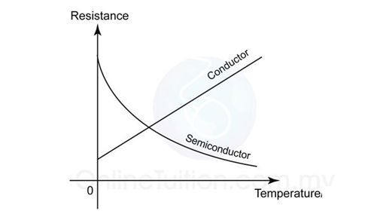

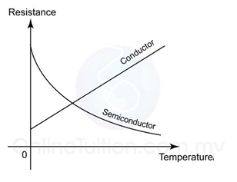

Figure 5.1: A graph that shows the changes in resistances of a conductor and a semiconductor with temperature. For conductor the resistance increases linearly and for semiconductor the resistance decreases exponentially with the temperature.

For a conductor the resistance increases with increase of temperature, as the figure 5.1 shows. If R1 is the resistance of a conductor at temperature θ1 and at a higher temperature θ2 the resistance raises to R2, then we can write

R2 = R1[1 + 𝛼 (𝜃2 − 𝜃1)] ……. (1)

where 𝛼 is the temperature coefficient of the material of the conductor.

Rearranging Eq. 1, we get

R2 = R1 + 𝛼R1(𝜃2 − 𝜃1)

=> 𝛼R1(𝜃2 − 𝜃1) = R2 − R1

=> 𝛼 = = ………… (2)

where ∆R= (R2 − R1) is the change in resistance due to the change in temperature ∆𝜃=(𝜃2−𝜃1).



In Eq. (2) if we put R1 =1 Ohm and ∆𝜃 = 10C we get 𝛼 = ∆R, thus we define the temperature coefficient of resistance of a substance as the change in resistance per unit resistance (per ohm) for unit change in temperature (per 0C). Also, we find the unit of 𝛼 as per 0C.

For a conductor, if we know the resistances R1 at a temperature θ1 and R2 at a higher temperature

θ2 , then we can calculate the temperature coefficient of resistance of its material by using the Eq.

2. The unknown resistance can be determined by a meter bridge that works with the Wheatstone

bridge principle.

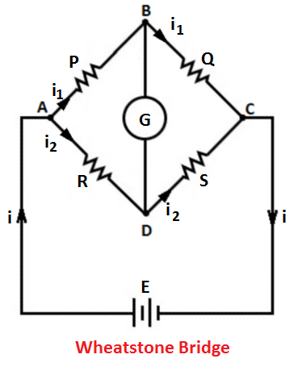

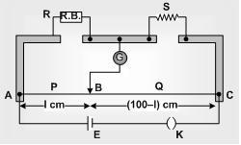

Figure 5.2: A meter bridge can be used to determine an unknown resistance by using the

Wheatstone bridge principle.

In the meter bridge circuit as in fig. 5.2, for the null deflection in the galvanometer we get

$$\frac{P}{Q}=\frac{R}{X}$$

=>𝑋= $\frac{Q}{P} ×R= \frac{ρ(100 - l)/A}{ρl/A}$ $×$ R = $\frac{100 - l}{l}$ $×$ R ……………..(3)

where 𝜌 is the specific resistance of the material and A is the cross-sectional area of the wire of the meter bridge.

According to Eq. (3) if we know the length of the balance point, l and the resistance, R we can determine the unknown resistance X.

1. **Apparatus**

* Power supply
* Meter bridge
* Galvanometer
* Jockey
* Resistance box
* Coil of conducting wire,
* Commutator,
* Thermometer
* Beeker
* Water
* Electric heater
* **Circuit Diagram for the experiment**

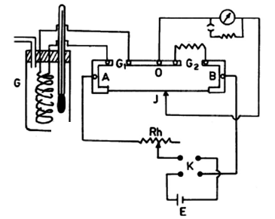

Figure: Circuit diagram for the experiment

1. **Procedure**

* Set up the apparatus as the circuit diagram shows in figure 5.3.
* First connect the coil of the wire in the left gap G1 and keep it inside the Beeker at room temperature. Note the temperature, θ1 from the thermometer. Connect the resistance box in the right gap G2 of the meter bridge. By closing the nobs in different positions of the commutator you can change the direction of current flow in the circuit. Take different resistances (say 5,7, 9 ohm) from the resistance box to find the position of the balance points on the wire of the meter bridge for direct current as well as reverse current.
* Now Connect the coil of the wire in the right gap G2 and the resistance box in the left gap G1. Find the balance points for direct current and reverse current for 5,7 and 9 ohms.
* Pour hot water in the Beeker to raise the temperature. Note the high temperature, θ2 from the thermometer. For different resistances (5,7 and 9 ohms) find the balance points for direct current as well as reverse current connecting the coil of the wire in the left gap then in the right gap.
* Calculate the value of unknown resistances for left gap and right gap by using the two equations given in the calculation part. Also calculate the temperature coefficient, 𝛼.

1. **Experimental Data**

Table 5.1: Readings balance point on meter bridge

|  |  |  |  |  |  |  |  |  |
| --- | --- | --- | --- | --- | --- | --- | --- | --- |
| Temperature  (0C) | Known resistance  R  Ohms | Position of unknown resistance  X | Position of Balance point, l (cm) | | Mean  l  (cm) | 100 – l  (cm) | X  (Ohms) | Mean  X  (Ohms) |
| Direct current | Reverse current |
| **θ 1 =24** | 5 | Left | 58.2 | 59.1 | 58.65 | 41.35 | 7.09 | **X1 =6.14** |
| Right | 49.5 | 50.5 | 50.00 | 50 | 5 |
| 7 | Left | 22.5 | 51.9 | 37.2 | 62.8 | 4.15 |
| Right | 54.5 | 51.8 | 53.15 | 46.85 | 6.17 |
| 9 | Left | 47.3 | 45.5 | 46.4 | 53.6 | 7.79 |
| Right | 59.3 | 55.9 | 57.6 | 42.4 | 6.63 |
| **θ 2 =80** | 5 | Left | 58.1 | 56.1 | 57.1 | 42.9 | 6.66 | **X2 =7.66** |
| Right | 44.5 | 40.2 | 42.35 | 57.65 | 6.81 |
| 7 | Left | 56.9 | 50.7 | 53.8 | 46.2 | 8.15 |
| Right | 46.7 | 49.6 | 48.15 | 51.85 | 7.54 |
| 9 | Left | 54.3 | 45.4 | 49.85 | 50.15 | 8.95 |
| Right | 52.6 | 54.1 | 53.35 | 46.65 | 7.87 |

1. **Calculation**

* For left gap: 𝑋= $\frac{l}{100-l} ×R$
* For right gap: 𝑋= $\frac{100-l}{l} ×R$
* Temperature coefficient of resistance, 𝛼 =

**=**

= 4.4210-3 C-1

1. **Result**

|  |  |  |
| --- | --- | --- |
| Temperature (0C) | Resistance (ohm) | Temperature coefficient of resistance (/0C) |
| 24 | 6.14 | 4.42 $×{10}^{-3}$ |
| 80 | 7.66 |

1. **Discussion**

* Care should be taken that the hypsometer and the burner do not heat any other electrical accessories of the experiment.
* While making preliminary adjustment the shunt for the galvanometer should be used. Final adjustment for the null points should be made without the shunt.

1. **References**

For further understanding students may go through the following resources:

* Fundamental of Physics (10th Edition): Resistance and resistivity (Chapter 26, page 755)
* Video Links:
* Temperature coefficient: https://www.youtube.com/watch?v=TgmOfi2rn0s
* Meter Bridge: https://www.youtube.com/watch?v=nqx8vIdHVkQ